**Summer Learning 2025 Registration**

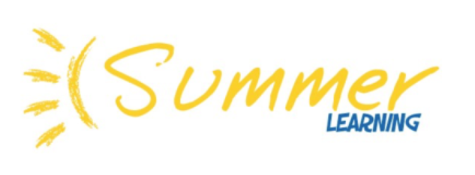

**Interested in signing your child(ren) for a Summer Learning Course?**

**Registration for Elementary students starts Monday April 21 @ 7PM!**

Did you know that Richmond Continuing Education Summer Learning Program is **FREE** (one free course) for BC students who are Canadian Citizens, Permanent Residents, who have refugee status and whose parents are living in BC with a valid work permit?

(Note: students entering grade 8 can register for up to three Secondary Enrichment courses.)

Summer camps for Elementary age students are also available at an additional cost.

Summer Learning 2025 Registration starts Monday April 21 at 7pm.

Don’t miss out!

**Check out all the exciting Summer Courses we are planning on offering this Summer Learning 2025! (Click on link below)**

[Summer 2025 Flyer](https://ce.sd38.bc.ca/files/ce/2025/04/Summer%20Learning%20Catalogue%202025.pdf)