**Kidd Week at a Glance**

**October 14th- October 18th**

**Upcoming Cultural Holidays & Commemorative Days of Recognition**

**Oct. 11 – 12 - Dussehra** - A major Hindu festival celebrated every year at the end of Durga Puja and Navaratri.

It is observed on the tenth day of the month of Ashvin.

**Oct. 11 – 12 - Yom Kippur** - Yom Kippur, the Day of Atonement, is known as the holiest day of the Jewish year.

**Oct. 14** **-** **Thanksgiving** – Celebrates the arrival of the fall harvest.

October is also Community Inclusion Month, German Heritage Month, Canadian Islamic History Month, Latin American Heritage Month and Women’s History Month

|  |  |
| --- | --- |
| **Monday**  Oct. 14th | **Thanksgiving Holiday – School is closed** |
| **Tuesday**  Oct. 15th |  |
| **Wednesday**  Oct. 16th | Grade 6/7 Volleyball Practice |
| **Thursday**  Oct. 17th | Fire Drill  S.H.A.R.P Assembly |
| **Friday**  Oct. 18th | Hot Lunch Day - Subway |

**PRINCIPAL’s MESSAGE**

With the upcoming holiday weekend, we wanted to take this opportunity to wish everyone a Happy Thanksgiving! This weekend provides an opportunity to think about what we are grateful for. Enjoy the long weekend!

**SCHOOL SUPPLY AND PLANNER PAID THROUGH SCHOOL CASH ONLINE**

To pay on-line, please go to the following website to register: <https://richmondsd38.schoolcashonline.com/>

When registering you will need your child’s pupil number. This is the number on the top of the blue Student Information Verification Form that was sent home this week. If you have not registered previously, you will also receive a School Cash Online letter with your child’s pupil number on it. Alternatively, you may email [kidd@sd38.bc.ca](mailto:kidd@sd38.bc.ca) for your child’s number.

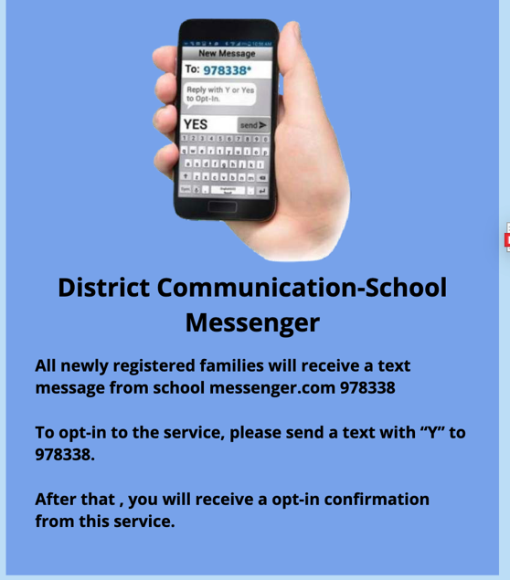**DISTRICT COMMUNICATION – SCHOOL MESSENGER**

The Richmond School District has an opt in messenger service that staff and families can access to receive updates.

**THOMAS KIDD GRAB AND GO FRIDGE AND SNACK AVAILABILITY**

At Thomas Kidd we have snacks available to students who need one throughout the day. **We will not be saying “no” to students who need food, but we will be encouraging them to make responsible decisions. This will help ensure that there is enough food for everyone so that we don’t run out.**

**PARKING LOT SAFETY**

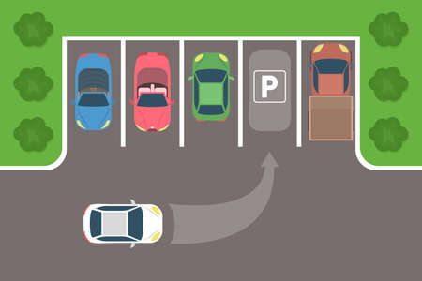There is limited space in our school parking lot. We ask that you take extra precaution by driving slowly and using designated parking spots when dropping off your child. Please do not drop off your child in the driving lanes as there are cars driving around and backing out of spots. **Please do not park on the North side of the school in the NO PARKING lane.**

Please talk to Mr. Cherry if you have any concerns about the parking lot. We are committed to the safety of our community.



**Mark your calendars - Dates will be added as we plan activities**

Oct 21 Kidd Volleyball Home game vs. Woodward

Oct 22 PAC Meeting at 6:30 pm in the library

Oct 23 Term 1 Conferences – early dismissal at 1:45pm

Oct 24 Term 1 Conferences – early dismissal at 1:45pm

Oct 25 Provincial Pro- D – school not in session

Oct 29 Pumpkin Carving

Oct 30 PAC bake sale after school

Oct 31 Halloween – Costume Parade

